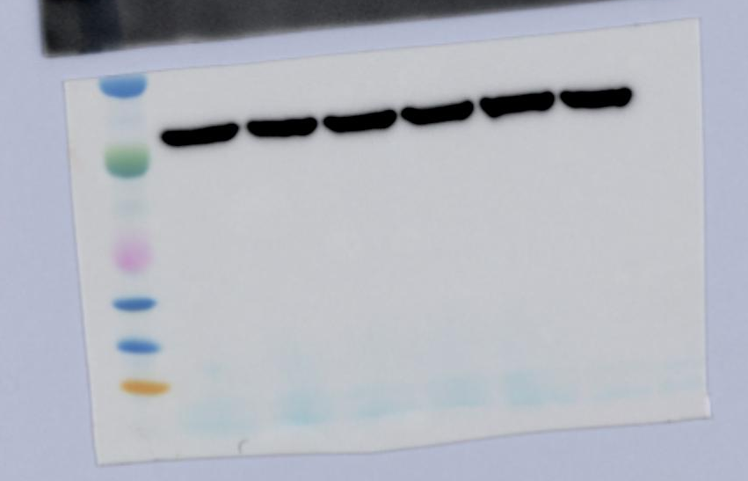
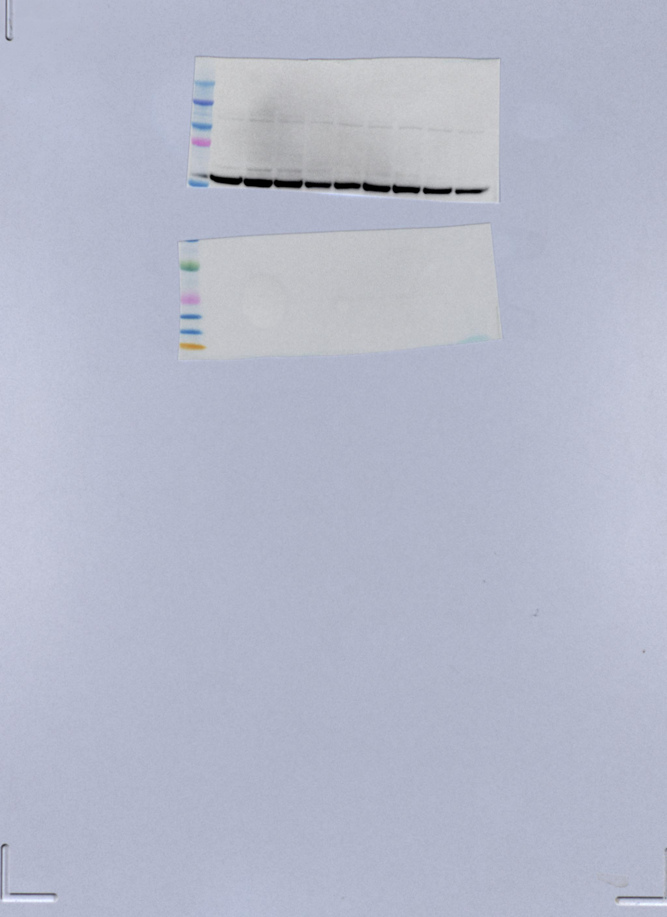

Figure 3 was chopped from above two figure, the left was AKT, the right was Actin.

